Name : Vishal Jha

Batch : Data Engineering

Date : 25-01-2024

Topic : SQL Coding Challenge (**Execute OVER and PARTITION BY Clause in SQL Queries ,creating subtotals &Total Aggregations using SQL Queries.)**

1. Created and Use database CodingChallenge1.

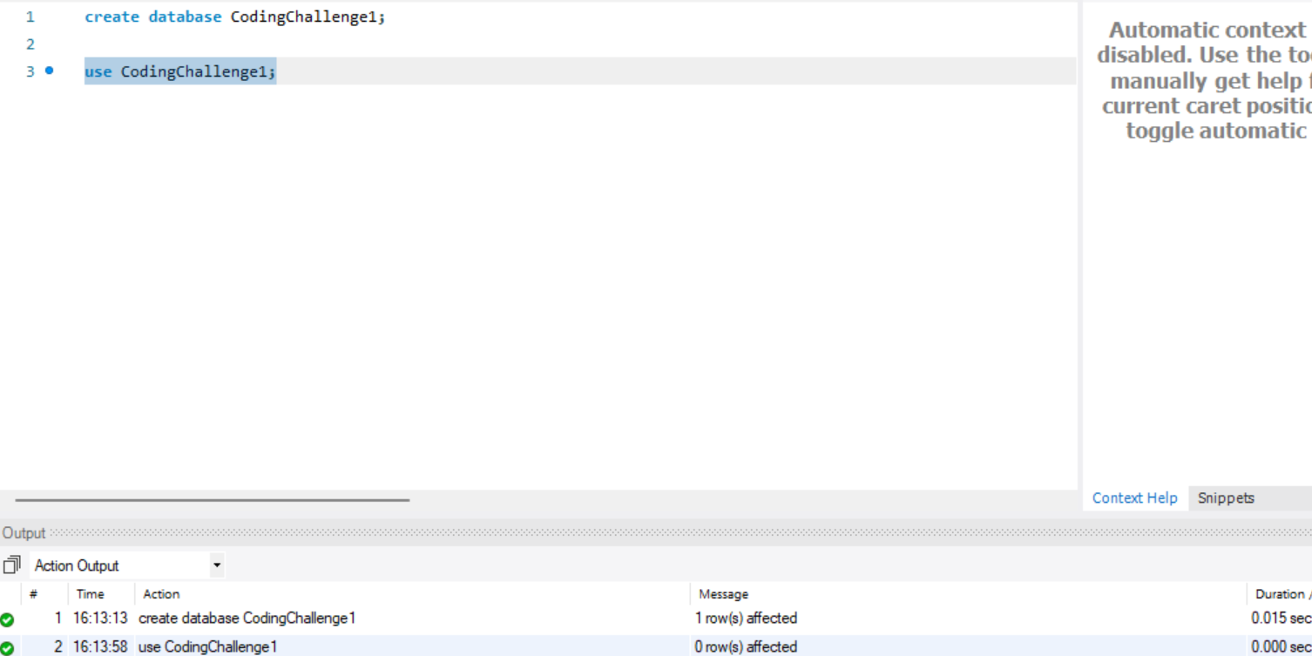

1. Created Table Customers and inserted some values.

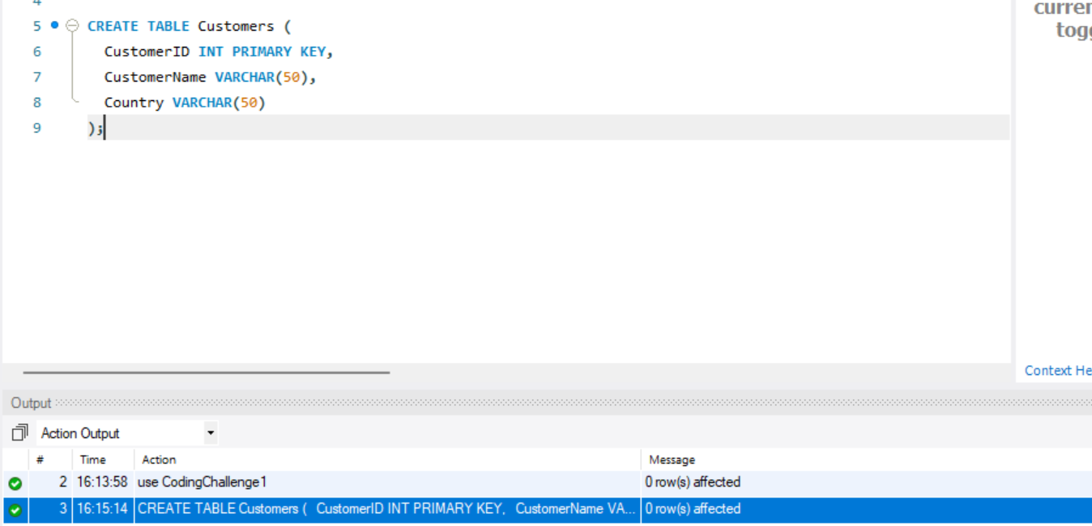

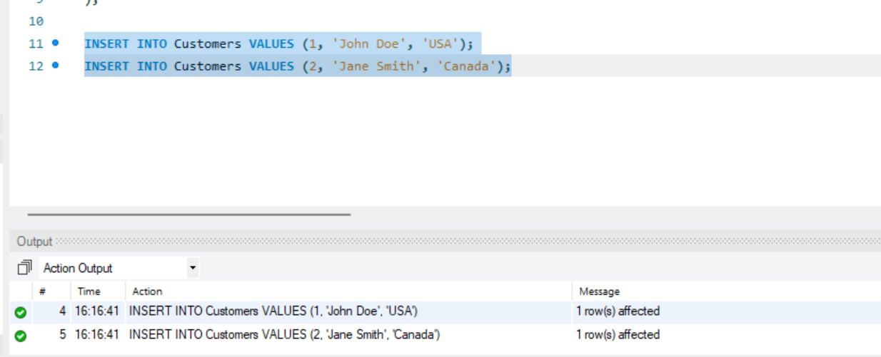

1. Created another table Orders and inserted some sample data.

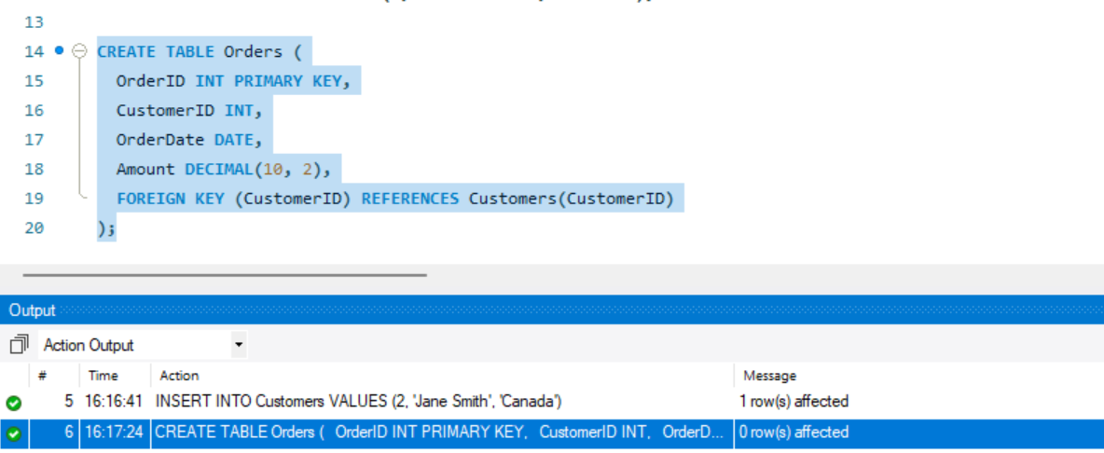

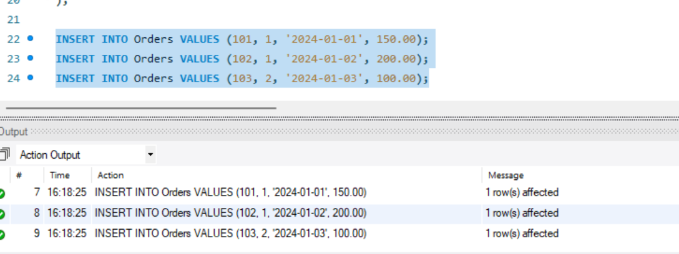

1. Subtotal using Partition by and Over clause.

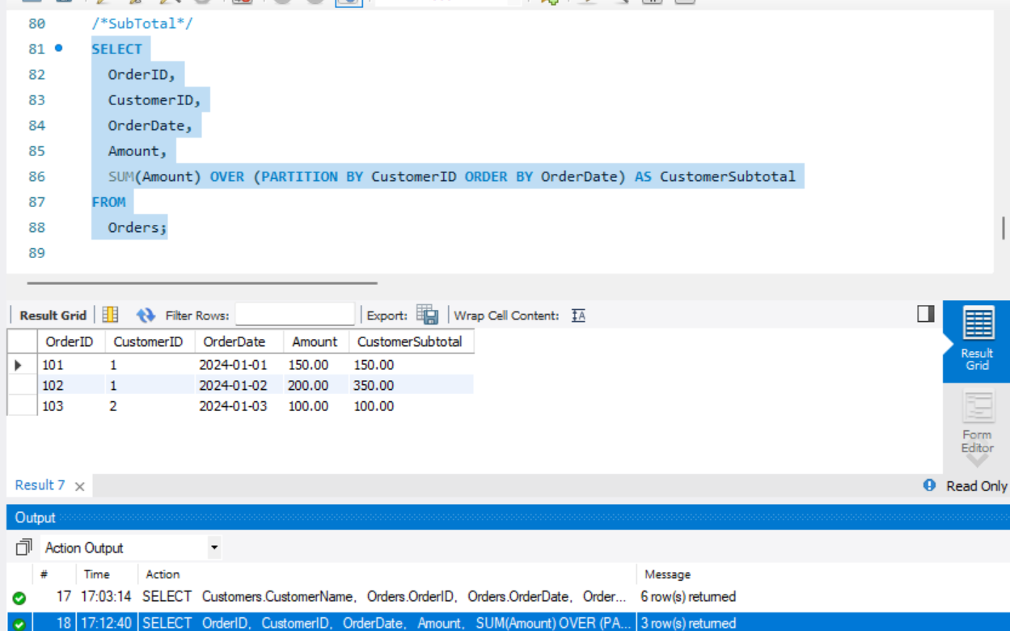

1. Total Aggregation.

